Lesson 7 – Websites II

**Task**:

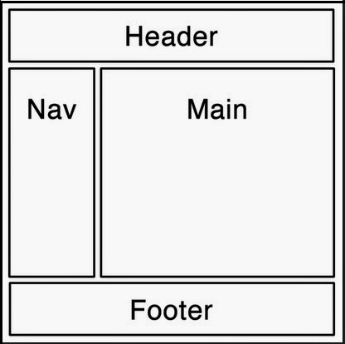- Finish *a website* according to the instructions from the previous lesson.

- Use **relative references** for links between pages and sources of images:

* <https://www.coffeecup.com/help/articles/absolute-vs-relative-pathslinks/>

- Make all the webpages **valid** according to HTML5 standards:

* <https://validator.w3.org/>

- Make the final site accessible via your **www** folder on NAS:

* Access the page via these links (don’t forget to replace **NameSurname** with your **login**):
  + unsecured HTTP protocol:
    - [http://gymeske.synology.me:1080/~**NameSurname**/index.html](http://gymeske.synology.me:1080/~NameSurname/index.html)
  + secured HTTPS protocol:
    - [https://gymeske.synology.me:1443/~**NameSurname**/index.html](https://gymeske.synology.me:1443/~NameSurname/index.html)

**Optional**:

- Add vector graphic elements to your web using either:

* HTML Canvas: <https://www.w3schools.com/html/html5_canvas.asp>
* Scalable Vector Graphics (SVG): <https://www.w3schools.com/html/html5_svg.asp>

- Add multimedia files to your web:

* Video: <https://www.w3schools.com/html/html5_video.asp>
* Audio: <https://www.w3schools.com/html/html5_audio.asp>
* YouTube: <https://www.w3schools.com/html/html_youtube.asp>